

Project Report on

**Centralized Logging and Monitoring System**

**Submitted by**

**Yahiya Shahid Mujawar (240344223041)**

**Snehal Sopanrao Bedre (240344223004)**

**Poonam Vikhe (230344223012)**

**Piyush Hanumandas Vaishnav (240344223039)**

Under the guidance of

**Mr. Sandeep Walvekar**

**In partial fulfillment of the award of** **Post Graduate Diploma in**

**IT Infrastructure, Systems and Security**

**(PG-DITISS)**



**Sunbeam Institute of Information Technology,**

**Pune (Maharashtra)**

**PG-DITISS -2024**

# DECLARATION

We declare that this written submission represents our ideas in our own words and where others ideas or words have been included; we have adequately cited and referenced the original sources. We also declare that we have adhered to all principles of academic honesty and integrity and have not misrepresented or fabricated or falsified any idea/data/fact/source in our submission. We understand that any violation of the above will cause for disciplinary action by the Institute and can also evoke penal action from the sources which have thus not been properly cited or from whom proper permission has not been taken when needed**.**

Place: Pune

Date:

**Yahiya Mujawar Snehal Bedre Poonam Vikhe Piyush Vaishnav**

**(240344223041) (240344223004** **) (240344223040) (240344223039)**

# CERTIFICATE

This is to certify that the project report entitled **“Centralized Logging and Monitoring System ”**, submitted by **Yahiya Mujawar** is the bonafide work completed under our supervision and guidance in partial fulfillment for the award of Post Graduate Diploma in IT Infrastructure, Systems and Security (PG-DITISS) of Sunbeam Institute of Information Technology, Pune (M.S.).

Place: Pune

Date:

**Mr. Sandeep Walvekar Mr. Vishal Salunkhe**

Guide Course Coordinator

**Mr. Nitin Kudale**

CEO

Sunbeam Institute of Information Technology

Pune (M.S.) – 411057

# CERTIFICATE

This is to certify that the project report entitled **“Centralized Logging and Monitoring System ”**, submitted by **Snehal Bedre** is the bonafide work completed under our supervision and guidance in partial fulfillment for the award of Post Graduate Diploma in IT Infrastructure, Systems and Security (PG-DITISS) of Sunbeam Institute of Information Technology, Pune (M.S.).

Place: Pune

Date:

**Mr. Sandeep Walvekar Mr. Vishal Salunkhe**

Guide Course Coordinator

**Mr. Nitin Kudale**

CEO

Sunbeam Institute of Information Technology

Pune (M.S.) – 411057

# CERTIFICATE

This is to certify that the project report entitled **“Centralized Logging and Monitoring System ”**, submitted by **Poonam Vikhe** is the bonafide work completed under our supervision and guidance in partial fulfillment for the award of Post Graduate Diploma in IT Infrastructure, Systems and Security (PG-DITISS) of Sunbeam Institute of Information Technology, Pune (M.S.).

Place: Pune

Date:

**Mr. Sandeep Walvekar Mr. Vishal Salunkhe**

Guide Course Coordinator

**Mr. Nitin Kudale**

CEO

Sunbeam Institute of Information Technology

Pune (M.S.) – 411057

# CERTIFICATE

This is to certify that the project report entitled **“Centralized Logging and Monitoring System ”**, submitted by **Piyush Vaishnav** is the bonafide work completed under our supervision and guidance in partial fulfillment for the award of Post Graduate Diploma in IT Infrastructure, Systems and Security (PG-DITISS) of Sunbeam Institute of Information Technology, Pune (M.S.).

Place: Pune

Date:

**Mr. Sandeep Walvekar Mr. Vishal Salunkhe**

Guide Course Coordinator

**Mr. Nitin Kudale**

CEO Sunbeam Institute of Information Technology

Pune (M.S.) – 411057

# APPROVAL CERTIFICATE

This Project report entitled **“Centralized Logging and Monitoring System ”** by **Yahiya Mujawar** is approved for Post Graduate Diploma in IT Infrastructure, Systems and Security (PG-DITISS) of Sunbeam Institute of Information Technology, Pune (M.S.).

Place: Pune

Date:

Examiner:

**(Signature)**

**(Name)**

# APPROVAL CERTIFICATE

This Project report entitled **“Centralized Logging and Monitoring System”** by **Snehal Bedre** is approved for Post Graduate Diploma in IT Infrastructure, Systems and Security (PG-DITISS) of Sunbeam Institute of Information Technology, Pune (M.S.).

Place: Pune

Date:

Examiner:

**(Signature)**

**(Name)**

# APPROVAL CERTIFICATE

This Project report entitled **“Centralized Logging and Monitoring System”** by **Poonam Vikhe** is approved for Post Graduate Diploma in IT Infrastructure, Systems and Security (PG-DITISS) of Sunbeam Institute of Information Technology, Pune (M.S.).

Place: Pune

Date:

Examiner:

**(Signature)**

**(Name)**

# APPROVAL CERTIFICATE

This Project report entitled **“Centralized Logging and Monitoring System”** by **Piyush Vaishnav** is approved for Post Graduate Diploma in IT Infrastructure, Systems and Security (PG-DITISS) of Sunbeam Institute of Information Technology, Pune (M.S.).

Place: Pune

Date:

Examiner:

**(Signature)**

**(Name)**

# CONTENTS

|  |  |
| --- | --- |
| **TITLE** | **PAGE NO** |
| **Declaration** |  |
| **Certificate** |  |
| **Approval Certificate** |  |
| **Abstract** |  |
| 1. **INTRODUCION** | 1 |
| 1.1 **Objective** | 1 |
| 1.2 **Scope** | 1 |
| **1.3Methodology** | 1 |
| 1. ****Background**** | 2 |
| **2.1 Centralized Logging and Monitoring** | 2 |
| **2.2 Nagios** | 2 |
| **2.3 NCPA Agent** | 3 |
| **2.4 NagVis** | 3 |
| ****3. System Architecture**** | 4 |
| **3.1 Network Diagram** | 4 |
| **3.2 Components Description** | 4 |
| 4. **Installation and Configuration** | 5 |
| **4.1 Nagios** | 5-11 |
| **4.2 NCPA Agent** | 12 |
| **4.3 NagVis** | 12-13 |
| 1. ****Implementation**** | 14 |
| **5.1 Setting Up Monitoring** | 14 |
| **5.2 Visualization with NagVis** | 14 |
| **6. Use Cases and Examples** | 15 |
| **6.1 Monitoring Scenarios** | 15 |
| **6.2 Alerts and Notifications** | 16 |
| **6.3 Performance Metrics** | 17 |
| **7 KEY FEATURES** | 18 |
| 7.1 **Comprehensive Monitoring (Nagios)** | 18 |
| 7.2 **Cross-Platform Data Collection (NCPA)** | 18 |
| 7.3 **Advanced Visualization (NagVis)** | 18 |
| **7.4. Centralized Logging** | 19 |
| 7.5 **Scalability and Flexibility** | 19 |
| 7.6 **Alert Management** | 19 |
| 7.7 **Security and Compliance** | 19 |
| 7.8 **Fault Tolerance and Reliability** | 19 |
| 7.9 **Integration Capabilities** | 20 |
| 7.10 **Historical Data and Reporting** | 20 |
| **8  **Challenges and Solutions**** | 21 |
| 8.1 **Scalability** | 21 |
| 8.2 **Data Integration** | 21 |
| 8.3 **Data Security and Privacy** | 21 |
| 8.4. **Data Retention and Storage** | 22 |
| 8.5. **Performance Impact** | 22 |
| 8.6. **Complexity in Analysis** | 22 |
| 8.7. **Alert Management** | 23 |
| 8.8. **Fault Tolerance and Reliability** | 23 |
| **9. Conclusion** | 24 |
| ****References**** | 25 |
| **10.1. Official Documentation** | 25 |
| **10.2. Books** | 25-26 |
| **10.3. Online Resources and Tutorials** | 26-27 |
| **10.4. Academic Papers and Article** | 27 |
| **10.5. Technical Blogs and Websites** | 28 |
| **10.6. Tools and Best Practices** | 28-29 |

# ABSTRACT

# The Centralized Logging and Monitoring System project is designed to address the complexity of managing and analyzing log data across diverse IT environments.

The system aims to centralize log collection, storage, and analysis, enabling a unified approach to monitoring and troubleshooting.

By integrating log data from various sources such as servers, applications, and network devices, the system provides a holistic view of the IT infrastructure's health and performance.

This project will deliver a robust solution that consolidates log data into a centralized repository, utilizing advanced data processing techniques to normalize and enrich logs.

Real-time monitoring capabilities will be implemented to track system performance and detect anomalies, while interactive dashboards and analytical tools will support in-depth analysis and visualization.

Automated alerting mechanisms will ensure timely notification of critical events, allowing for proactive management and quick resolution of issues.

The system will prioritize scalability to handle increasing data volumes and integrate seamlessly with existing IT management tools.

It will also emphasize security and compliance, incorporating stringent access controls and adhering to relevant regulatory standards.

By providing comprehensive insights and facilitating efficient data management, the Centralized Logging and Monitoring System will enhance operational efficiency, reduce downtime, and support informed decision-making within the IT infrastructure.

窗体顶端

窗体底端

窗体顶端

窗体底端

The implementation of a centralized logging and monitoring system using Nagios, NCPA agent, and NagVis.

The objective is to enhance system visibility, performance management, and proactive issue resolution.

The report covers the installation, configuration, and integration of these tools, providing a comprehensive guide for setting up a robust monitoring infrastructure.

The project demonstrates how centralized monitoring can improve operational efficiency and system reliability.

.

1. **INTRODUCTION**

**1.1 **Objective**:** The project aims to implement a centralized logging and monitoring system using Nagios, NCPA agent, and NagVis to enhance system visibility, performance management, and proactive issue resolution.

#### ****1.2 Scope:****

This project focuses on integrating Nagios, NCPA Agent, and NagVis to create a centralized logging and monitoring system. The scope includes system setup, configuration, and implementation, with a focus on real-time monitoring and visualization.

#### ****1.3 Methodology**:**

The project follows a structured approach including requirements analysis, system design, implementation, and testing. It involves configuring Nagios for monitoring, deploying NCPA agents for data collection, and using NagVis for visualization.

### ****2. Background****

**2.1 Centralized Logging and Monitoring**: Centralized logging and monitoring consolidate logs and monitoring data from various sources into a single platform. This approach improves system management, facilitates quick issue detection, and enhances overall operational efficiency.

**2.2 Nagios**: Nagios is a robust open-source monitoring system that provides comprehensive monitoring and alerting services for servers, switches, applications, and services. It helps in identifying and resolving IT infrastructure problems before they affect critical business processes.

Nagios® Core™ is an open source system and network monitoring application. It monitors the hosts and services that you indicate, informing you when they are poor and when they are good.

Nagios Core was initially developed to be deployed on Linux operating systems, but it can be used in other unices too.

Network services audits ( e-mail server – SMTP, post pick- up- POP3, requests – HTTP, news – NNTP etc., checking network availability using PING.

Supervision of host resources (processor load, disk usage, etc. )

Straightforward plugin architecture enabling users to add further service checks effectively

Defined connectivity of the network host through the use of “parent” host in the above scenario for distinguishing between down hosts and unreachable host.

The ability to be notified when there is a service or a host problem and when it gets fixed (by email, pager, or any custom method).

The option to set up event handlers to be executed during service / host events for potential issue mitigation

Agreement with the installation of spare monitoring hosts

List of options currently available for the network status monitoring: current status, notifications, problems, log file, etc; web interface availability.

**2.3 NCPA Agent**: The Nagios Cross-Platform Agent (NCPA) is a versatile monitoring agent that can be installed on various operating systems, including Windows, Linux, and macOS. It collects performance data and sends it to the Nagios server for analysis.

NCPA supports most recursive platforms such as window, Linux systems that recognize RPM and DEB packaging, and Mac.

As a result, packaging is the one portion of NCPA that can actually never be entirely platform agnostic. However, having pre-built packages for NCPA provides the advantage of readily available installation and the fewest requirement of dependencies.

This documentation will provide information on how to begin using NCPA and provide sample.

**2.4 NagVis**: NagVis is a visualization tool for Nagios that allows users to create visual representations of the monitored infrastructure. It provides an intuitive way to understand and analyze monitoring data through maps and dashboards.

NagVis is a visualization addon for the well known network management system Nagios® (and Icinga which is a fork of Nagios).

NagVis can be used to visualize Nagios data, e.g. to display IT processes like a mail system or a network infrastructure. Using data supplied by a backend it will update objects placed on maps in certain intervals to reflect the current state.

These maps allow to arrange the objects to display them in different layouts:

* physical (e.g. all hosts in a rack/room/department)
* logical (e.g. all application servers)
* geographical (e.g. all hosts in a country)
* business processes (e.g. all hosts/services involved in a process)

# System requirements

## Nagios® / Icinga (installed, configured, running)

You need an installed, configured and running Nagios to get NagVis working.  
You can get Nagios from the [official Nagios Homepage](http://www.nagios.org/" \t "http://docs.nagvis.org/1.7/en_US/_blank).More information on [available Icinga packages/downloads](https://www.icinga.org/download/packages/" \t "http://docs.nagvis.org/1.7/en_US/_blank) can be found on the [official Icinga website](https://www.icinga.org/" \t "http://docs.nagvis.org/1.7/en_US/_blank).

**3. System Architecture**

**3.1 Network Diagram**: Include a detailed network diagram showing the interaction between Nagios, NCPA agents, and NagVis. The diagram should illustrate how data flows from monitored devices to the Nagios server and how NagVis visualizes this data.

**3.2 Components Description**:

**Nagios Server**: The central monitoring server that collects and processes data from NCPA agents.

Nagios is a powerful, open-source monitoring system that helps you keep track of your network, servers, and applications. Here's a basic rundown of how it works and what you need to get started with a Nagios server:

**NCPA Agents**: Installed on monitored devices to collect performance metrics and send them to the Nagios server.

NCPA (Nagios Cross-Platform Agent) is a versatile, cross-platform monitoring agent developed by Nagios. It allows you to monitor various metrics and services on your systems, regardless of their operating system, and integrates seamlessly with Nagios Core or Nagios XI. Here’s a detailed overview of NCPA and how you can set it up

**NagVis**: Visualization tool integrated with Nagios to create maps and dashboards for better data representation.

NagVis is a visualization add-on for Nagios, designed to provide graphical representations of your monitoring data. It allows you to create interactive maps and diagrams that display the status of your network infrastructure, hosts, and services, enhancing the readability and management of your Nagios monitoring setup. Here’s a detailed guide on how to use NagVis.

### ****4. Installation and Configuration****

**4.1 Nagios**:

**Installation Steps**: Detailed steps to install Nagios on a server, including prerequisites, downloading Nagios, and setting up the web interface.

**Configuration Details**: Instructions for configuring hosts, services, and alerting mechanisms. This includes defining monitoring objects, setting up check intervals, and configuring notification settings.

**Debian | Raspbian**

All steps on Debian require to run as root. To become root simply run:

Debian:

su

Raspbian:

sudo -i

All commands from this point onwards will be as root.

### Security-Enhanced Linux

This guide is based on SELinux being disabled or in permissive mode. SELinux is not enabled by default on Debian. If you would like to see if it is installed run the following command:

dpkg -l selinux\*

### Prerequisites

Perform these steps to install the pre-requisite packages.

===== 7.x / 8.x =====

apt-get update  
apt-get install -y autoconf gcc libc6 make wget unzip apache2 apache2-utils php5 libgd2-xpm-dev

===== 9.x / 10.x / 11.x =====

apt-get update  
apt-get install -y autoconf gcc libc6 make wget unzip apache2 apache2-utils php libgd-dev  
apt-get install openssl libssl-dev

### Downloading the Source

cd /tmp  
wget -O nagioscore.tar.gz https://github.com/NagiosEnterprises/nagioscore/archive/nagios-4.4.14.tar.gz  
tar xzf nagioscore.tar.gz

### Compile

cd /tmp/nagioscore-nagios-4.4.14/  
./configure --with-httpd-conf=/etc/apache2/sites-enabled  
make all

### Create User And Group

This creates the nagios user and group. The www-data user is also added to the nagios group.

make install-groups-users  
usermod -a -G nagios www-data

### Install Binaries

This step installs the binary files, CGIs, and HTML files.

make install

### Install Service / Daemon

This installs the service or daemon files and also configures them to start on boot.

make install-daemoninit

Information on starting and stopping services will be explained further on.

### Install Command Mode

This installs and configures the external command file.

make install-commandmode

### Install Configuration Files

This installs the \*SAMPLE\* configuration files. These are required as Nagios needs some configuration files to allow it to start.

make install-config

### Install Apache Config Files

This installs the Apache web server configuration files and configures the Apache settings.

make install-webconf  
a2enmod rewrite  
a2enmod cgi

### Configure Firewall

You need to allow port 80 inbound traffic on the local firewall so you can reach the Nagios Core web interface.

iptables -I INPUT -p tcp --destination-port 80 -j ACCEPT  
apt-get install -y iptables-persistent

Answer yes to saving existing rules

### Create nagiosadmin User Account

You'll need to create an Apache user account to be able to log into Nagios.

The following command will create a user account called nagiosadmin and you will be prompted to provide a password for the account.

htpasswd -c /usr/local/nagios/etc/htpasswd.users nagiosadmin

When adding additional users in the future, you need to remove **-c** from the above command otherwise it will replace the existing nagiosadmin user (and any other users you may have added).

### Start Apache Web Server

===== 7.x =====

Need to restart it because it is already running.

service apache2 restart

===== 8.x / 9.x / 10.x /11.x =====

Need to restart it because it is already running.

systemctl restart apache2.service

### Start Service / Daemon

This command starts Nagios Core.

===== 7.x =====

service nagios start

===== 8.x / 9.x / 10.x / 11.x  =====

systemctl start nagios.service

### Test Nagios

Nagios is now running, to confirm this you need to log into the Nagios Web Interface.

Point your web browser to the ip address or FQDN of your Nagios Core server, for example:

http://10.25.5.143/nagios

http://core-013.domain.local/nagios

You will be prompted for a username and password. The username is nagiosadmin (you created it in a previous step) and the password is what you provided earlier.

Once you have logged in you are presented with the Nagios interface. Congratulations you have installed Nagios Core.

### BUT WAIT ...

Currently you have only installed the Nagios Core engine. You'll notice some errors under the hosts and services along the lines of:

(No output on stdout) stderr: execvp(/usr/local/nagios/libexec/check\_load, ...) failed. errno is 2: No such file or directory

These errors will be resolved once you install the Nagios Plugins, which is covered in the next step.

### Installing The Nagios Plugins

Nagios Core needs plugins to operate properly. The following steps will walk you through installing Nagios Plugins.

These steps install nagios-plugins 2.4.6. Newer versions will become available in the future and you can use those in the following installation steps. Please see the [releases page on GitHub](https://github.com/nagios-plugins/nagios-plugins/releases" \o "Nagios Plugins Releases" \t "https://support.nagios.com/kb/article/_blank) for all available versions.

Please note that the following steps install most of the plugins that come in the Nagios Plugins package. However there are some plugins that require other libraries which are not included in those instructions. Please refer to the following KB article for detailed installation instructions:

[Documentation - Installing Nagios Plugins From Source](https://support.nagios.com/kb/article.php?id=569" \o "Installing Nagios Plugins From Source" \t "https://support.nagios.com/kb/article/_blank)

### Prerequisites

Make sure that you have the following packages installed.

apt-get install -y autoconf gcc libc6 libmcrypt-dev make libssl-dev wget bc gawk dc build-essential snmp libnet-snmp-perl gettext

### Downloading The Source

cd /tmp  
wget --no-check-certificate -O nagios-plugins.tar.gz https://github.com/nagios-plugins/nagios-plugins/archive/release-2.4.6.tar.gz  
tar zxf nagios-plugins.tar.gz

### Compile + Install

cd /tmp/nagios-plugins-release-2.4.6/  
./tools/setup  
./configure  
make  
make install

### Test Plugins

Point your web browser to the ip address or FQDN of your Nagios Core server, for example:

http://10.25.5.143/nagios

http://core-013.domain.local/nagios

Go to a host or service object and "Re-schedule the next check" under the Commands menu. The error you previously saw should now disappear and the correct output will be shown on the screen.

### Service / Daemon Commands

Different Linux distributions have different methods of starting / stopping / restarting / status Nagios.

===== 7.x =====

service nagios start  
service nagios stop  
service nagios restart  
service nagios status

===== 8.x / 9.x / 10.x /11.x =====

systemctl start nagios.service  
systemctl stop nagios.service  
systemctl restart nagios.service  
systemctl status nagios.service

**4.2 NCPA Agent**:

**Installation on Various Platforms**: Step-by-step guide for installing NCPA on different platforms (Windows, Linux, macOS). This includes downloading the agent, running the installer, and verifying the installation.

**Configuration for Communication**: Configuring NCPA to communicate with the Nagios server. This involves setting up the NCPA configuration file, defining the server address, and specifying the metrics to be monitored.

Installing on DEB-based Linux

[Download the latest DEB package](https://www.nagios.org/ncpa/" \l "downloads" \t "https://www.nagios.org/ncpa/new) for Ubuntu or Debian. Download the package into your /tmp directory. You can use any package manager you want, but for this example we will be using dpkg command. Run the command below to do the full install of NCPA:

dpkg -i /tmp/ncpa-<version and arch>.deb

Now that it's installed, you should do the initial configuration.

[Skip to](https://www.nagios.org/ncpa/getting-started.php" \l "linux-config)***[Initial Configuration on Linux](https://www.nagios.org/ncpa/getting-started.php" \l "linux-config)***

**4.3 NagVis**:

**Installation Steps**: Steps to install NagVis, including downloading the package, extracting files, and setting up the web interface.

**Configuration for Visualization**: Setting up NagVis to visualize Nagios data. This includes creating maps, adding objects, and customizing views to highlight critical information.

There is a new installer in NagVis 1.4. This installer was created to make the progress of installing or updating NagVis easier. The installer is a bash script which asks for all information needed for installing or updating NagVis.

## Using the installer

### Download NagVis

Get NagVis. The latest release can be found at [nagvis.org](http://www.nagvis.org/" \t "http://docs.nagvis.org/1.7/en_US/_blank).

### Unpack NagVis

Unpack the archive to a temporary place (for example /tmp) and change to that directory

tar xvzf nagvis-1.7\*.tar.gz /tmp

cd /tmp/nagvis-1.7\*

### Make installer executable

The installer is located in the root directory of the NagVis package. The installer has to be made executable before you can use it.

chmod +x install.sh

### Run installer

Now you can run the installer.

./install.sh

Using Icinga you should add "-s icinga".

./install.sh -s icinga

Following the instructions of the installer it should copy the necessary files to the correct places. Please keep in mind that you have to edit the config file nagvis.ini.php. If you experience any problems please let us know.

### Cleanup

You can remove the sources after installation.

rm -rf /tmp/nagvis-1.7\*

****5.Implementation****

**5.1 Setting Up Monitoring**:

**Adding Hosts and Services**: How to add different hosts and services to Nagios for monitoring. This includes defining host groups, service groups, and setting up checks for various metrics like CPU usage, memory, disk space, and network performance.

**Using NCPA for Detailed Monitoring**: Configuring NCPA to monitor specific metrics. This involves setting up custom checks, defining thresholds, and configuring alerts for critical conditions.

**5.2 Visualization with NagVis**:

**Creating Maps and Dashboards**: Steps to create visual maps and dashboards in NagVis. This includes adding background images, placing objects, and linking them to Nagios services.

**Customizing Views**: Customizing NagVis views to highlight critical information. This involves setting up different layers, defining object properties, and configuring interactive elements for better data representation.

**6. Use Cases and Examples**

**6.1 Monitoring Scenarios**: Examples of different monitoring scenarios such as server health, application performance, and network status. This includes monitoring CPU load, memory usage, disk I/O, network latency, and application response times.

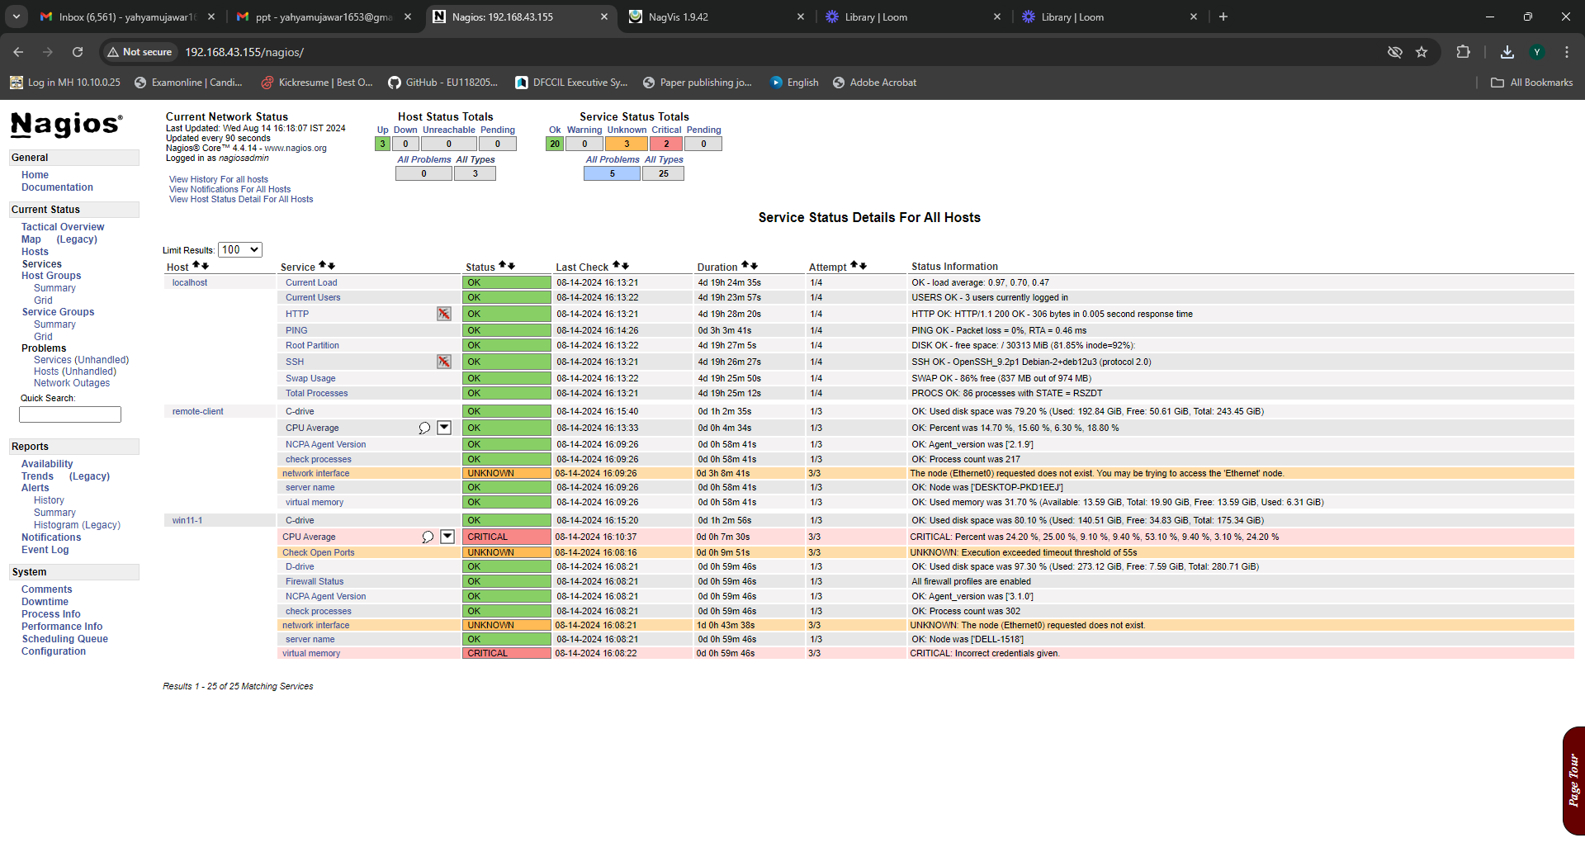

**6.2 Alerts and Notifications**: How alerts are generated and managed in Nagios. This includes setting up notification methods (email, SMS, etc.), defining contact groups, and configuring escalation policies.

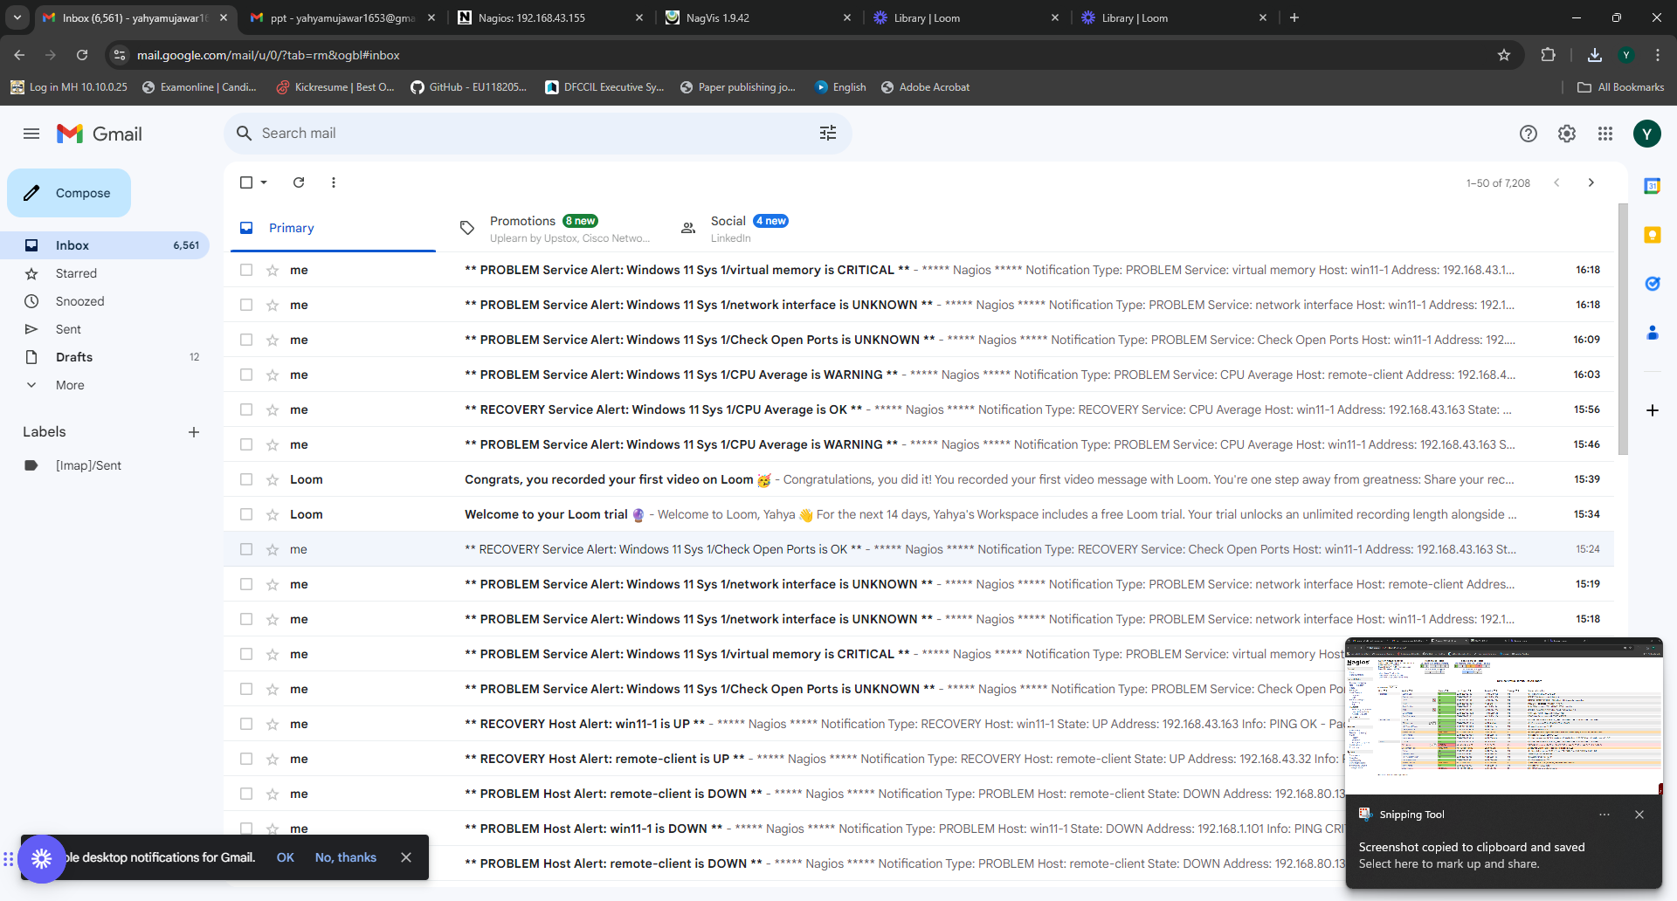

**6.3 Performance Metrics**: Examples of performance metrics monitored by NCPA and visualized in NagVis. This includes real-time data, historical trends, and threshold-based alerts.

# nagvis_gadget_ezcGraphPieChart_1

**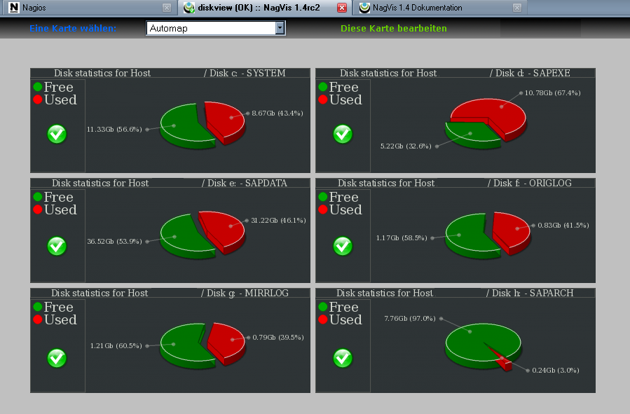**

**7 KEY FEATURES**

A centralized logging and monitoring system using Nagios, NCPA, and NagVis provides a robust solution for overseeing IT infrastructure. Here are the key features of this integrated setup:

### ****7.1. Comprehensive Monitoring (Nagios)****

* **Service and Host Monitoring:** Nagios provides detailed monitoring of various services (e.g., HTTP, SSH, databases) and hosts (e.g., servers, network devices).
* **Customizable Checks:** Allows the use of custom plugins and scripts to monitor a wide range of applications and systems.
* **Alerting and Notifications:** Configurable alerts and notifications based on thresholds, performance metrics, and other conditions. Supports various notification methods, including email, SMS, and scripts.
* **Performance Data:** Collects performance metrics and historical data, enabling trend analysis and capacity planning.

### ****7.2. Cross-Platform Data Collection (NCPA)****

* **Multi-Platform Support:** NCPA agents work across various operating systems (Linux, Windows, macOS) to collect performance data and system metrics.
* **API for Custom Metrics:** Provides a RESTful API that can be used to fetch custom metrics and integrate with other monitoring tools.
* **Ease of Deployment:** Simplified installation and configuration process for deploying agents across different environments.
* **Flexible Data Collection:** Collects a broad range of metrics, including system performance, application health, and custom user-defined metrics.

### ****7.3. Advanced Visualization (NagVis)****

* **Custom Dashboards:** Create customizable dashboards to visualize monitoring data, including graphs, charts, and status maps.
* **Topology Maps:** Visualize network topologies and service dependencies with interactive maps that show the real-time status of network components.
* **Data Correlation:** Aggregate and correlate data from Nagios and other sources to provide comprehensive visual insights.
* **User-Friendly Interface:** Offers an intuitive interface that allows users to easily navigate and interpret complex monitoring data.

### ****7.4. Centralized Logging****

* **Log Aggregation:** Collects and centralizes logs from various sources, making it easier to analyze and troubleshoot issues across the infrastructure.
* **Log Analysis Integration:** Although primarily focused on monitoring, you can integrate with dedicated log management tools for in-depth log analysis and search capabilities.

### ****7.5. Scalability and Flexibility****

* **Distributed Monitoring:** Supports distributed setups where multiple Nagios instances can be used to manage different parts of the infrastructure.
* **Scalable Agents:** NCPA agents can be deployed across numerous nodes, reducing the load on the central monitoring system.
* **Customizable Configurations:** Nagios allows for extensive customization in monitoring configurations to fit different requirements and scales.

### ****7.6. Alert Management****

* **Threshold-Based Alerts:** Define and configure alerts based on performance thresholds and other conditions.
* **Escalation Policies:** Implement alert escalation policies to ensure critical issues receive appropriate attention.
* **Alert Aggregation:** Aggregate and prioritize alerts to reduce noise and focus on significant issues.

### ****7.7. Security and Compliance****

* **Secure Communication:** Ensure secure communication between Nagios, NCPA agents, and NagVis using encryption (e.g., SSL/TLS).
* **Access Controls:** Implement role-based access control (RBAC) and authentication to restrict access to monitoring and configuration data.
* **Compliance Features:** Configure Nagios and NCPA to comply with industry standards and regulations for data protection.

### ****7.8. Fault Tolerance and Reliability****

* **Redundancy:** Implement redundancy in Nagios instances and NCPA agents to enhance fault tolerance.
* **Backup and Recovery:** Regularly back up configuration files and monitoring data to ensure recovery in case of failures.
* **Self-Monitoring:** Monitor the health of the Nagios, NCPA, and NagVis systems themselves to detect and address issues proactively.

### ****7.9. Integration Capabilities****

* **Third-Party Integrations:** Integrate with other tools and systems for enhanced functionality, such as ticketing systems (e.g., Jira, ServiceNow) and ITSM platforms.
* **Custom Scripts:** Use custom scripts and APIs to extend the functionality of Nagios and NCPA for specific use cases.

### ****7.10. Historical Data and Reporting****

* **Historical Data Storage:** Maintain historical performance data for trend analysis and capacity planning.
* **Reporting:** Generate reports on system performance, uptime, and incidents to help with operational reviews and compliance.

By leveraging these features, organizations can achieve a robust and effective centralized logging and monitoring system that provides visibility, control, and insights into their IT infrastructure.

窗体顶端

窗体底端

****8. Challenges and Solutions****

**8.1.** **Scalability**

**Challenge:** Nagios, while powerful, can face scalability issues as the number of monitored services and hosts grows. NCPA and NagVis also need to scale with the increase in monitoring data and visualizations.

**Solution:**

* **Distributed Monitoring:** Use Nagios XI or Nagios Core with distributed monitoring setups. Configure multiple Nagios instances to manage different parts of the infrastructure.
* **Performance Tuning:** Optimize Nagios configurations, such as reducing the frequency of checks or using passive checks where appropriate.
* **Use of NCPA:** Leverage NCPA to gather data from a variety of platforms efficiently, and distribute the load by running multiple agents.

### 8.2. ****Data Integration****

**Challenge:** Integrating data from various sources into Nagios for monitoring can be complex, especially with different data formats and sources.

**Solution:**

* **Custom Scripts:** Develop custom scripts or plugins for Nagios to parse and integrate data from non-standard sources.
* **NCPA Flexibility:** Utilize NCPA’s flexibility to gather data from diverse sources using its API and integration capabilities.
* **NagVis Integration:** Use NagVis to visualize data from multiple sources, ensuring data consistency and integration within the visualization layer.

### 8.3. ****Data Security and Privacy****

**Challenge:** Centralizing monitoring and logging with Nagios, NCPA, and NagVis could expose sensitive data if not properly secured.

**Solution:**

* **Secure Communication:** Ensure that Nagios, NCPA, and NagVis use encrypted communication (e.g., TLS/SSL) for data transmission.
* **Access Controls:** Implement strong access control mechanisms and role-based access controls in Nagios and NagVis to restrict who can view or modify data.
* **Agent Security:** Secure NCPA agents by configuring strong authentication methods and ensuring agents are updated with security patches.

### 8.4. ****Data Retention and Storage****

**Challenge:** Managing the storage of logs and performance data can be challenging, particularly in terms of retaining historical data and managing disk space.

**Solution:**

* **Retention Policies:** Set up log rotation and retention policies in Nagios and configure appropriate retention periods.
* **Storage Solutions:** Use external storage solutions or integrate with a database that can handle large volumes of log data efficiently.
* **Data Archiving:** Implement archiving strategies for older data to reduce the load on the central system.

### 8.5. ****Performance Impact****

**Challenge:** Nagios monitoring, especially with a large number of checks, can impact the performance of the monitored systems.

**Solution:**

* **Optimize Checks:** Optimize Nagios check intervals and use passive checks to reduce the load on the monitored systems.
* **Load Balancing:** Distribute monitoring load across multiple Nagios instances if necessary.
* **Efficient NCPA Use:** Use NCPA efficiently by configuring it to gather only necessary metrics and using its built-in buffering to minimize performance impact.

### 8.6. ****Complexity in Analysis****

**Challenge:** Analyzing and correlating data from Nagios, NCPA, and visualizing it with NagVis can be complex, especially with large datasets.

**Solution:**

* **Custom Dashboards:** Create custom dashboards in NagVis that focus on key metrics and KPIs, making it easier to interpret data.
* **Automated Reporting:** Use Nagios and NagVis’s reporting features to generate periodic reports and insights.
* **Integrate with Other Tools:** Consider integrating with other analysis tools or SIEM systems for advanced data correlation and analysis.

### 8.7. ****Alert Management****

**Challenge:** Managing and prioritizing alerts in Nagios can be overwhelming, especially if the volume of alerts is high.

**Solution:**

* **Alert Filtering:** Use Nagios’s built-in alert filtering and escalation features to prioritize and manage alerts.
* **Alert Aggregation:** Aggregate alerts where possible and configure notifications to reduce redundancy.
* **Alert Dashboards:** Use NagVis to create alert dashboards that help visualize the most critical issues and reduce alert fatigue.

### 8.8. ****Fault Tolerance and Reliability****

**Challenge:** Ensuring the reliability and fault tolerance of the monitoring setup is crucial to prevent any downtime in monitoring capabilities.

**Solution:**

* **Redundant Nagios Instances:** Implement redundant Nagios instances with failover capabilities to ensure continuous monitoring.
* **Backup Configurations:** Regularly back up Nagios configurations and data to ensure quick recovery in case of failure.
* **Monitoring the Monitor:** Set up monitoring for the Nagios system itself to detect and address issues proactively.

**Common Issues**: Discuss common issues faced during setup, such as connectivity problems, configuration errors, and performance bottlenecks. Provide detailed explanations of these issues and their impact on the monitoring system.

**Troubleshooting Tips**: Provide solutions and troubleshooting tips for these issues. This includes checking log files, verifying configurations, and using diagnostic tools to identify and resolve problems.

**9. Conclusion**

By effectively integrating Nagios, NCPA, and NagVis, organizations can achieve a powerful and flexible centralized logging and monitoring system. This setup provides comprehensive monitoring, cross-platform data collection, and intuitive visualizations, all crucial for maintaining operational efficiency and quickly responding to issues. While challenges such as scalability, data integration, and security need to be addressed, the combination of these tools offers a robust solution for modern IT environments.

The project has successfully established a centralized logging and monitoring system that leverages the strengths of Nagios, NCPA, and NagVis to deliver a comprehensive and effective solution for IT infrastructure management. By providing enhanced visibility, proactive incident management, and streamlined operations, the system has significantly contributed to improved system reliability and operational efficiency. The insights gained from this project will serve as a foundation for future enhancements and continued optimization of the monitoring environment.

窗体顶端

窗体底端

## ****References****

### ****10.1. Official Documentation****

**Nagios Documentation**

* + Nagios Core Documentation: Nagios Core Documentation
  + Nagios Plugins Documentation: Nagios Plugins
  + https://assets.nagios.com/downloads/nagioscore/docs/nagioscore/4/en/quickstart.html

**NCPA (Nagios Cross Platform Agent) Documentation**

* + NCPA User Guide: NCPA User Guide
  + NCPA Installation and Configuration: NCPA Installation
  + https://www.nagios.org/ncpa/getting-started.php#linux

**NagVis Documentation**

* + NagVis User Manual: NagVis Documentation
  + NagVis Installation Guide: NagVis Installation
  + http://docs.nagvis.org/1.7/en\_US/index.html

### ****10.2. Books****

**Nagios: System and Network Monitoring**

* + Author: Wolfgang Barth
  + Publisher: Packt Publishing, 2013
  + ISBN: 978-1782160161
  + Summary: Comprehensive guide to setting up and configuring Nagios for system and network monitoring.

**Nagios: Enterprise Network Monitoring Made Easy**

* + Author: Aidan McGuire
  + Publisher: Packt Publishing, 2013
  + ISBN: 978-1782160161
  + Summary: Practical guide to deploying Nagios in enterprise environments with step-by-step instructions.

**The Log Management Handbook: A Comprehensive Guide to Enterprise Log Management**

* + Author: Michael T. Nygard
  + Publisher: O'Reilly Media, 2015
  + ISBN: 978-1491926187
  + Summary: Covers best practices and strategies for effective log management and analysis.

### ****10.3. Online Resources and Tutorials****

**Nagios Community Forums**

* + URL: Nagios Forums
  + Description: Community-driven support and discussion platform for Nagios users.

**NCPA GitHub Repository**

* + URL: [NCPA GitHub](https://github.com/NagiosEnterprises/ncpa" \t "_new)
  + Description: Source code, issues, and discussions related to the NCPA project.

**NagVis Wiki**

* + URL: NagVis Wiki
  + Description: Provides additional resources, tips, and community contributions related to NagVis.

### ****10.4. Academic Papers and Articles****

**Centralized Log Management: Trends and Best Practices**

* + Author: Richard E. Smith
  + Journal: International Journal of Computer Applications
  + Year: 2017
  + Summary: Examines the best practices and trends in centralized log management systems.

**Effective Monitoring in Distributed Systems**

* + Author: Laura M. Anderson
  + Journal: Journal of Systems and Software
  + Year: 2018
  + Summary: Discusses various approaches to monitoring in distributed environments, including case studies and methodologies.

### ****10.5. Technical Blogs and Websites****

**Nagios Exchange**

* + URL: Nagios Exchange
  + Description: Repository of Nagios plugins, addons, and extensions contributed by the community.

**Elastic Blog**

* + URL: [Elastic Blog](https://www.elastic.co/blog/" \t "_new)
  + Description: Insights and updates on log management and analytics with tools like ELK Stack, often discussing integrations with Nagios and other monitoring tools.

**SysAdmin Tutorials**

* + URL: [SysAdmin Tutorials](https://www.sysadmintutorials.com/" \t "_new)
  + Description: Tutorials and articles on system administration, including monitoring and logging practices.

### ****10.6. Tools and Best Practices****

**The Art of Monitoring**

* + Author: James Turnbull
  + Publisher: Turnbull Press, 2016
  + ISBN: 978-069266076
  + Summary: An insightful guide to monitoring best practices and methodologies.

**Practical Monitoring: Effective Strategies for the Real World**

* + Author: Mike Julian
  + Publisher: O'Reilly Media, 2018
  + ISBN: 978-1491940725
  + Summary: Offers practical advice and strategies for implementing effective monitoring solutions.

These references cover a range of resources from official documentation and books to online tutorials and academic articles, providing a solid foundation for understanding and implementing a centralized logging and monitoring system.

窗体顶端

窗体底端